Junior Cert Oral Exam- Role Plays

Role-plays are worth 60% of the marks of the oral exam (48 marks). There are two sections (A & B). You must do one task from each section (2 x 24 marks)

Section A: Task 1

You and a friend are visiting a French town and you ask an ‘agent de police’ how to get to the tourist office. Your friend doesn’t speak French and you will have to explain the directions to him / her in English.

- Attract the policeman’s attention:
YOU: Excusez- moi Monsieur, pouvez- vous m’aider? (Excuse me Sir, can you help me please ?)
EXAMINER: Oui, Mademoiselle / Monsieur? (Yes, Miss/ Sir?)

- Ask him how to get to the tourist office:
YOU: Où se trouve l’office de tourisme? (Where is the tourist office situated ?)
EXAMINER: L’office de Tourisme. Voyons. Vous continuez cette rue, vous traversez le pont là-bas, et c’est la deuxième rue à gauche. (The tourist office. Let’s see. You continue on this street, you cross the bridge over there, and it is the second street to the left.)

- Tell him that you don’t understand and ask him to repeat what he said:
YOU: Excusez-moi, monsieur, je ne comprends pas. Pouvez-vous répéter ça? (Excuse me Sir, I don’t understand. Can you repeat that ?)
EXAMINER: Vous continuez cette rue, vous traversez le pont là-bas, et c’est la deuxième rue à gauche.

- (Your friend wants to know what he said.) Repeat the directions in English as if explaining to your friend:
YOU: You continue on this street, you cross the bridge over there, and it is the second street to the left.

- Ask the policeman if it’s far.
YOU: C’est loin d’ici? (Is it far from here?)
EXAMINER: Non, c’est tout près. Vous en avez pour cinq minutes à pied. (No, it is very close. It is five minutes by foot)

- Thank him for his help.
YOU: Je vous remercie, Monsieur pour toute votre aide (I thank you, Sir for all your help)
EXAMINER: À votre service, Mademoiselle / Monsieur. (At your service Miss/ Sir)

Section A: Task 2

You go into the clothes department of a store to buy a jumper. The examiner will play the role of the salesperson and will start up the conversation.

- Greet the shop-assistant. Explain that you want to buy a jumper.
EXAMINER: Bonjour Mademoiselle / Monsieur. Je peux vous aider? (Hello Miss/ Sir. Can I help you?)
YOU: Bonjour Mademoiselle. Je veux acheter un pull (Hello Miss. I want to buy a jumper)

- Answer as you wish.
EXAMINER: Quelle couleur préférez-vous? (Which colour do you prefer ?)
YOU: Je préfère le pull rouge (I prefer the red jumper)

- (The salesperson shows you a jumper.) Ask if you can try it on.
EXAMINER: Voici le pull rouge (Here is the red jumper)
YOU: Je pourrais l’essayer s’il vous plaît? (Could I try it please ?)
EXAMINER: Oui. Il y a une glace là-bas. (Yes, there is a mirror over there)

- (You try it on but it’s too big for you.) Tell the salesperson it is too big.
YOU: Excusez-moi Mademoiselle, c’est trop grand (Excuse me Miss, it is too big)

- (The salesperson gives you another one to try on. You like it.) Ask how much it costs.
EXAMINER: Ah oui. Tenez, en voilà un autre plus petit. (Ah yes, here is another smaller one)
YOU: Je l’adore! Ça coûte combien? (I love it ! How much does it cost?)
EXAMINER: Ce pull-là coûte 60 euros, Mademoiselle / Monsieur. (This jumper costs sixty euro, Miss/ Sir)

Section A: Task 3

You are a customer in this restaurant. The examiner will play the role of the waiter.
Choose a dish from each of the three courses offered and something to drink.
Ask for the bill and check if service is included.

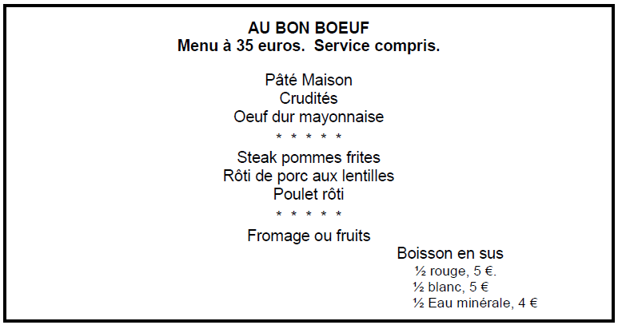

- Choose a dish from the three courses offered
EXAMINER: Bonjour, Monsieur / Mademoiselle. Vous désirez? (Hello, Sir/ Miss. What would you like?)
YOU: Bonjour Monsieur. Oui, j’ai choisi. Comme entrée, je voudrais le pâté maison. Comme plat principal, je voudrais le steak pommes frites et comme dessert, je voudrais le fromage. (Hello Sir, Yes I have chosen. As a starter, I would like the house paté. As main course, I would like the steak and chips and as dessert, I would like the cheese)

- Choose something to drink
EXAMINER: Et comme boisson ? (And as a drink?)
YOU: Comme boisson, je voudrais un verre de vin rouge s’il vous plaît. (As a drink, I would like a glass of red wine please)

- Ask for the bill
YOU: L’addition, s’il vous plaît. (The bill, please)
EXAMINER: Voilà, Monsieur / Mademoiselle. Quarante euro, s’il vous plait. (Here, Sir/ Miss. Forty euro, please)

- Check if service is included
YOU: Le service est compris? (Is the service included?)
EXAMINER: Oui, Monsieur / Mademoiselle. Le service est compris. (Yes Sir/ Miss. The service is included)

Section B: Task 1

You and your friend are hiking in France. You seek accommodation in an Auberge de Jeunesse (Youth Hostel). Your friend doesn’t speak French so you have to book in for both of you. You have to act as an interpreter for your friend. The examiner will play the role of the ‘Père Aubergiste’ in charge of the hostel.

- Ask if there are rooms for two people for the night.
YOU: Il y a une chambre pour deux personnes pour la nuit? (Is there a room for two people for the night?)
EXAMINER: Oui, il y a de la place. (Yes, there is room)

- Ask how much it costs.
YOU: Ça coûte combien? (How much does that cost?)
EXAMINER: Vingt euros par personne la nuit. (Twenty euro per person per night)

- Repeat what you are told in English as if explaining to your friend.
YOU: Twenty euro per person per night

- Ask where the kitchen is.
YOU: Où se trouve la cuisine? (Where is the kitchen situated ?)
EXAMINER : C’est au bout du couloir, à gauche. (It is at the bottom of the corridor, to the left)

- Repeat what you are told in English as if explaining to your friend.
YOU: It is at the bottom of the corridor, to the left.

Section B: Task 2

You are with a friend in a railway station in France. Your friend doesn’t speak French and you are helping him/her to buy a return ticket to Paris and to find out when the next train is leaving. You have to act as an interpreter for your friend. The examiner will play the role of the ticket clerk at the ‘guichet’.

- Ask for a return ticket to Paris.
YOU: Un billet aller-retour à Paris, s’il vous plaît (A return ticket to Paris, please)
EXAMINER: Voilà. 40 euros. (Here you go. €40)

- Ask the ticket clerk to repeat what he said.
YOU: Pouvez- vous répéter ça s’il vous plaît (Can you repeat that please)
EXAMINER: Quarante euro. (€40)

- Translate what he said into English as if explaining to your friend.
YOU: The ticket is forty euro

- Ask what time the next train to Paris is at.
YOU: Le prochain train à Paris part à quelle heure? (The next train to Paris leaves at what time?)
EXAMINER: À quatorze heures vingt-deux (At 14.22)

- Say the departure time in English as if interpreting for your friend.
YOU: The next train to Paris leaves at 14.22

Section B: Task 3

The examiner will play the part of your French pen-friend. You want to know more about his or her school.

- Find out how many pupils there are and
YOU: Il y a combien d’élèves dans votre école? (How many students are in your school?)
EXAMINER: Il y a environ 900 élèves. (There is around 900 students)

- Then say whether you think it’s a big or small school.
YOU: Ooh la la!! C’est une grande école! (Ooh la la!! It is a big school!)
EXAMINER: Oui, c’est assez grand. (Yes, it is quite big)

- Find out what time classes start and finish at.
YOU: Les cours commencent et finissent à quelle heure? (The classes start and finish at what time?)
EXAMINER: Les cours commencent à 8h30 et se terminent à 16h30. (The classes start at 8.20 and finish at 4.30)

- Ask what are his/her favourite subjects and
YOU: Quest-ce que c’est ta matière préférée? (What is your favourite subject?)
EXAMINER: Ma matière préférée est la géographie (My favourite subject is geography)

- Then say what subjects you prefer (or are good or bad at)
YOU: Moi, ma matière préférée est l’irlandais. C’est très facile et le prof est sympa (Me, my favourite subject is Irish. It is very easy and the teacher is nice)

- Ask if the teachers are strict.
YOU: Est-ce que les profs sont stricts? (Are the teachers strict?)
EXAMINER: Ça dépend. Un ou deux sont un peu sévères, mais en général ça va. Ils sont plutôt sympas. (It depends. One or two are a bit strict, but in general, it’s ok. They are rather nice)

- Find out if there are sports facilities (e.g. gymnasium, swimming pool, football) and
YOU: Il y a beaucoup d’équipements sportifs dans ton école? (Are there a lot of sports facilities in your school?)
EXAMINER: Oui, il y a un gymnase, une piscine et des tennis. (Yes, there is a gym, a pool and tennis)

- Then say what sports facilities there are in your school.
YOU: Dans mon école, il y a un terrain de foot, un gymnase et une piste d’athlétisme (In my school, there is a football pitch, a gym and a running track)

