Filíocht- Mo Ghrá-sa idir lúibíní (My love –in brackets)
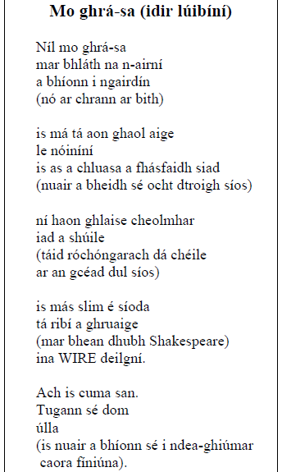
Téama (Theme)
- Baineann an dán seo le grá
This poem deals with love
- Níl a fear dathúil ach is aoibhinn léi é
Her man isn’t handsome but she loves him
- Mar tugann sé úlla di
Because he gives her apples (happiness)
- Níl a fear cosúil le bláth na n-airní
Her man is not like the blackthorn flower
Íomhánna (Imagery)
- Luann sí sreigne deilgní agus súile ró-chóngarach dá chéile
She mentions thorny wires and eyes too close to each other
- Tá sí ag caint faoina fear gránna
She is talking about her ugly man
- Chomh maith leis sin, luann sí úlla agus caora finiúna
Aswell as that, she mentions apples and grapes
- Tá sí ag caint faoi na bronntanais a thugann sé di
She is talking about the presents he gives her.
Mothúcháin (Feelings)
- Tá grá sa dán seo. Níl a fear dathúil ach tá sí i ngrá leis ar aon nós
There is love in the poem. Her man is not handsome but she is in love with him anyway
- Tá sástacht sa dán. Tá an file sásta lena grá
There is satisfaction in this poem. The poet is satisfied with her love
Friotal (language)
- Tá an friotal simplí sa dán seo
The language is simple in this poem
- Tá cúig véarsa gearra sa dán
There are five short verses in the poem
An maith leat an dán?
- Is maith liom an dán mar go bhfuil an téama suimiúil agus tá na pictiúir go hiontach sa dán.
I like the poem because the theme is interesting and the pictures are wonderful in the poem

Filíocht- Mo Ghrá-sa idir lúibíní (My love –in brackets)- CLEACHTADH
- Líon na Bearnaí
- ________________ an dán ____________ le grá
This poem deals with love
- ___________ a fear dathúil __________ is aoibhinn léi é
Her man isn’t handsome but she loves him
- Mar _____________ sé úlla ___________
Because he gives her apples (happiness)
- ____________ sí sreigne deilgní agus súile ró-ghar dá chéile
She mentions thorny wires and eyes too close to each other
- Tá sí ag caint ____________ fear _______________
She is talking about her ugly man
- _________ _________ _______ _______, luann sí úlla agus caora finiúna
Aswell as that, she mentions apples and grapes
- Tá sí ag caint faoi na _________________ a thugann sé ______
She is talking about the presents he gives her.
- Tá grá sa dán seo. Níl a fear dathúil ach tá sí ____ ____________ leis
There is love in the poem. Her man is not handsome but she is in love with him
- Tá ______________ sa dán. Tá an file sásta _________ grá
There is satisfaction in this poem. The poet is satisfied with her love
- Tá an friotal simplí _______ dán _______
The language is simple in this poem
- Tá cúig véarsa _________ sa dán
There are five short verses in the poem

- Scríobh as Gaeilge:
- This poem deals with talking
- Handsome she is
- She loves her man isn’t
- Him he gives
- About satisfaction
- As well as that language
- She mentions short
- Short Verses love
- Thorny wires too close to each other
- To her in love
- Daisies flower

- Scríobh as Béarla:
- Luann sí gearr
- Baineann an dán seo le ag caint
- Dathúil tá sí
- Is aoibhinn léi níl a fear
- di I ngrá
- é tugann sé
- sreigne deilgní róchóngarach dá chéile
- faoi sástacht
- véarsaí gearra grá
- chomh maith leis sin friotal
- nóiníní bláth

- Fregair na ceisteanna:
- Cad a dúirt an file faoin bhfear I véarsa a haon?
- Cá bhfásfaidh na nóiníní?
- Cad atá mícheart le súile an fhir?
- Cad a dúirt an file faoi ghruaige an fhir?
- Cad iad na torthaí a thugann an fhear don fhile?
- Cén saghas duine é an fear? (dhá phointe)
- Cén saghas duine í an file? (dhá phointe)
- Cad is téama don dán?
- Scríobh síos íomhá amháin atá greannmhar.
- An maith leat an dán seo? (Luaigh dhá fháth)

